ECEN 340
Lab #8

Static Sequential Memories and Tri-State Buses

Purpose:
1. To learn how to design Static Memories
2. To learn how to deal with tri-state (3-state) data buses
3. To learn to trust simulation for sub modules
4. To gain experience understanding Verilog code written by someone else.

Overview:
The objective of this lab is to implement a synchronous memory project that will be used for future projects.

Synchronous memory simply means that it may be accessed at a pre-determined clock rate. Loading the memory in this lab will be done by hand via the switches. Therefore, the second half of this lab will require the use of switches, buttons, and LEDs to interface with the memory.

Procedure:
Part 1. Simulating a single 16 X 16 Static memory.
a) Design the 16 X 16 Static RAM module called "memory". Note that the cell ports are: we, oe, data, addr, and clk. The data is accessed via a bi-directional 16-bit bus. See class slides for details on memory arrays (class slides are duplicated below).

b) Write a test bench to verify functionality of the memory (class slides are duplicated below).

module memory(
input wire oe, we, clk,
input wire [14:0] addr,
inout wire [7:0] data
);
reg [7:0] mem [32767:0];

assign data = (oe && !we) ? mem[addr]:8’hzz;
always@(posedge clk)
begin
if (we) mem[addr] <= data;
end
endmodule
Note: The above code will synthesize a memory that is 32768 X 8bit. Understand the difference between this memory and the 16 X 16bit memory of this lab.

module memory_tb( );
reg we, oe, clk;
wire [7:0] data;
reg [3:0] addr;
reg [7:0] data_temp;
parameter period = 10;
memory u0 (.we(we), .oe(oe), .clk(clk), .data(data), .addr(addr));

assign data = we?data_temp:8'hZZ;
always #(period/2) clk = ~clk;
initial
begin clk = 0; oe = 0; we = 0; addr = 4’h0; data_temp = 8’h00;
#5 we = 1'b1;
@(posedge clk)
#1 addr = 4'h0; data_temp = 8'h34; // wait 1 ns before writing
#period addr = 4'h1; data_temp = 8'h58; // writing to memory
#period addr = 4'h2; data_temp = 8'hA5;
#period addr = 4'h3; data_temp = 8'h5A;
…
#period addr = 4'h0; we= 1'b0; oe = 1'b1; // reading from memory
#period addr = 4'h1;
#period addr = 4'h2;
…
#1000 $finish
end
endmodule
Note: The above code is a test bench excerpt for the memory module.
Part 2. Implement the complete lab in Vivado. Homework 8 will serve as the foundation for understanding this lab. You will need:
1) Your four digit 7-segment display modules.
2) Your "memory" module
3) The pre-written modules provided.

You will not need to write a test bench for this part of the lab. When the lab is completely implemented, you will observe that the top-level design instantiates two 16 X 16 SRAM cells, 5 push-button debouncers, and the seven-segment design of Lab 6.

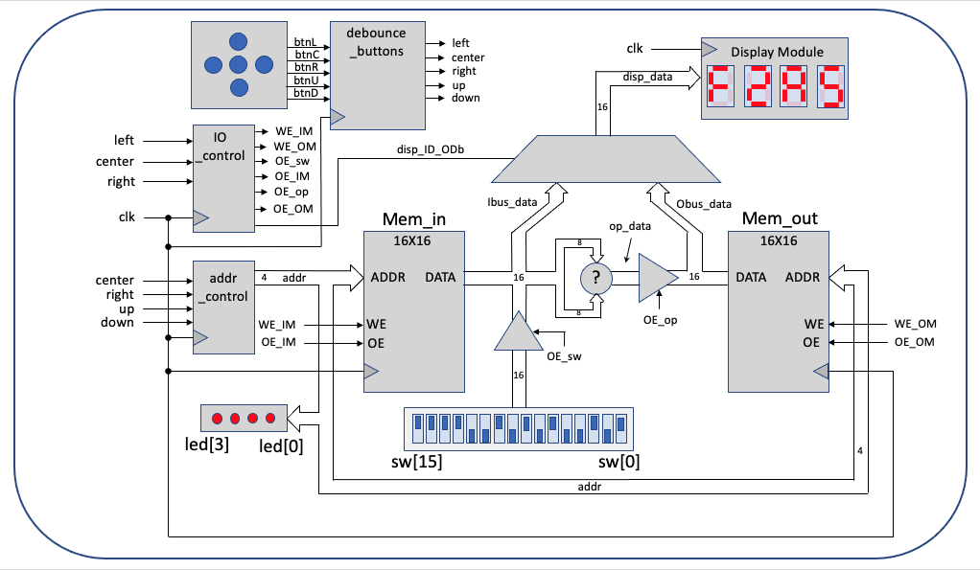
Block Diagram of 3-state Memory Lab

Submitting your report:
Please submit a combined report for both parts of this lab which should include the following:

1) A copy of the test bench used to verify the functionality of part 1 of this lab. The test bench code should include useful comments (5 pts).

2) A description of the new tools, technologies, or concepts used to implement this lab (5 pts).

3) Include Vivado screen shots of simultations, the elaborated schematic of the entire system, and other meaningful information to document your work (5 pts).

4) In your conclusion statement, please discuss your results, the method of testing, and include the level of functionality of the lab (10 pts).

